**Website Planning Document Peer Review**

**Juan Valencia WDD230**

**Site Purpose**

The mission is to provide fresh and healthy food options, including organic, made to order, fruit drinks and fruit bags, to the local population and to tourists visiting the coastal areas. The theme should support healthy eating, organic bounty, and convenience.

**Target Audience**

Persona 1: People who consider themselves vegetarians because they like healthy eating.

Persona 2: families with children, because their parents will want to help their sons to grow in a healthy way.

**Site Map**

FRESH

ABOUT US

RESOURCE

HOME

**Color Scheme** [Link](https://coolors.co/palette/64d633-ffffff-000000)

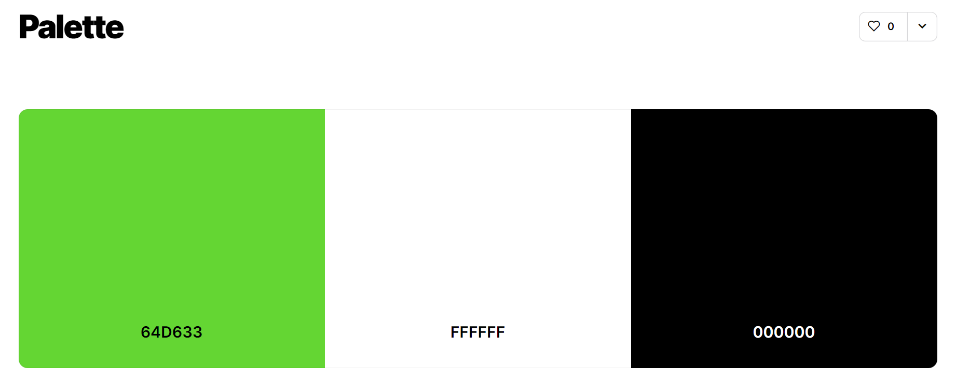

**Typography** [Link](https://fonts.google.com/share?selection.family=Noto%20Sans%20KR:wght@500%7CPacifico%7CSolway:wght@300)

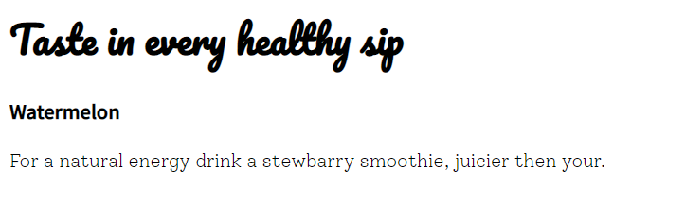

1. Navigation bar, heading, (Noto Sans Kr)
2. Name of products, titles (Pacifico)
3. Paragraph (Solway)

**Wireframe Sketches**

**Large Screen** [**Link**](https://wireframe.cc/lwOLET)

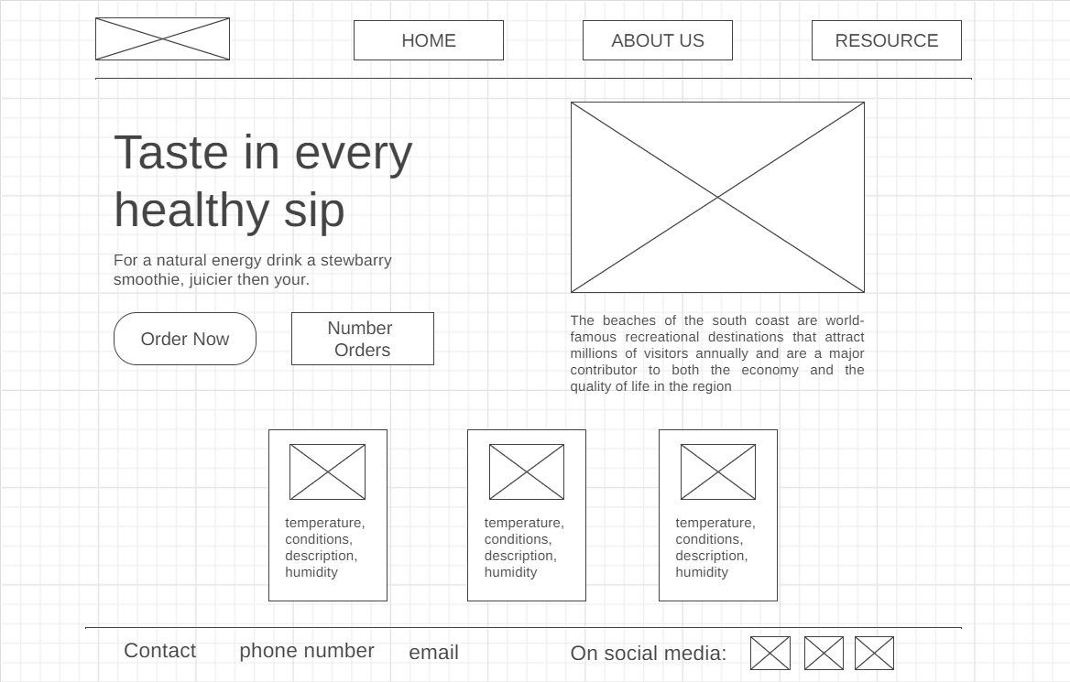

**Medium Screen** [**Link**](https://wireframe.cc/qlzkAm)

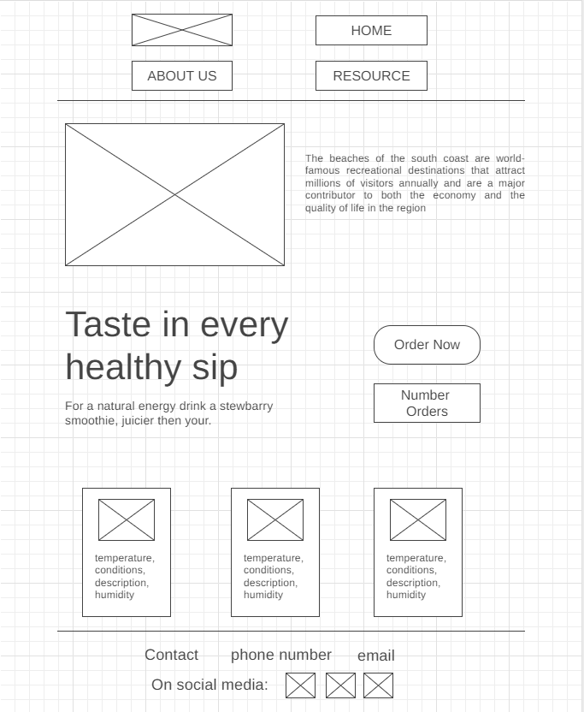

Small Screen [Link](https://wireframe.cc/PS5K8H)

